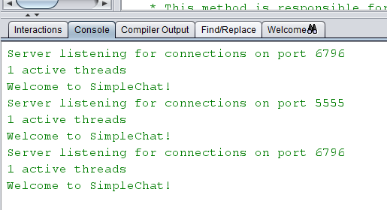Part 1 Q3.

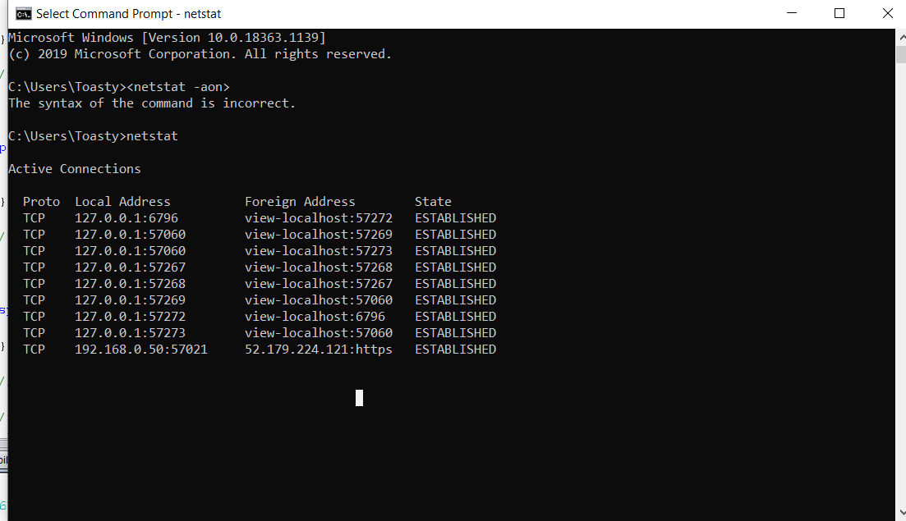

Part 2 Q1

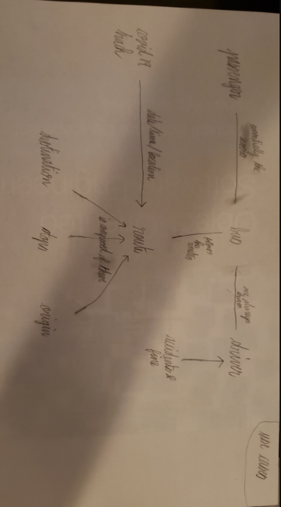

Route

String destination

String origin

String[] listOfStops

String[] arrivalTime

Covid[] tracker

Int routeNumber

String[] peakHours

Driver

int yearsExp

int[] fines

String[] accidentDate

Int shiftTime

Bus

String type

Person

String name

Int ID

1…\* 1…\*

Passengers

int prestoBalance

Boolean ticket

1

0…\* 0...\*

Covid

String location

String date

String time

1

1

Part 2 Q3.

Functional req

-System must recognize the type of bus the driver is allowed to drive based on their experience

-System must keep track of how many Covid-19 reported areas the bus and bus driver has been in contact with

-System must assign drivers to new routes that have no/few drivers

-System must track the total number of hours worked in a drivers shift throughout all routes they were assigned and calculate overtime for each

-System must terminate a driver who is at fault for 3 accidents or has over $1000 in fines

-System must remove terminated driver from shift schedules

-System must allow passengers to check bus routes

-System must allow passengers to choose between buying a ticket or paying with presto

-System must allow passengers to recharge their presto credit

-System must allow passengers to view their current presto balance

-System must deny passengers who are not permitted to board, no ticket/insufficient credits

Non-Functional req

-Driver should not get more than 10 hour shifts and 5 routes in a single day

-Passenger’s payments should be processed within 1 minute

-Reassignments of bus routes should take less than 24 hours after a driver has been removed from schedule

-Passengers should get notified of any changes made to bus routes and schedules made withing the last 24 hours of the changes

-Drivers should get notified of their termination within 12 hours of termination